Bug Report for Failed Test Case Execution for search box

🐞 Bug Report 01
Bug ID: BUG-001
Related Test Case: Search_1
Title: System doesn’t show validation message for empty search input.
Description:
When the user clicks the Search button or presses Enter without entering any text, the system does not show any validation or warning message. The search page loads with no results instead of prompting the user to enter a keyword.
Steps to Reproduce:
- Open https://demo.evershop.io/
- Keep the search field empty.
- Press Enter or click the Search icon.
Expected Result:
System should not crash, should display a validation message like “Please enter a keyword.
Actual Result:
No validation message is displayed; page shows blank or “no product to display.”
Severity: Major
Priority: High
Status: Open
Environment: Chrome (v128), Windows 10, https://demo.evershop.io/
Notes: Basic user input validation missing — can cause confusion and poor UX.

🐞 Bug Report 02
Bug ID: BUG-002
Related Test Case: Search_13
Title: Partial keyword search not returning results.
Description:
Typing a partial product name (e.g., “Nik”) in the search bar returns “No product to display” instead of showing results for “Nike” products.
Steps to Reproduce:
- Go to https://demo.evershop.io/
- In the search bar, type Nik
- Press Enter
Expected Result:
The search should return all items with names partially matching the term (e.g., Nike Zoom Fly, Nike React Infinity Run).
Actual Result:
System displays “No product to display.”
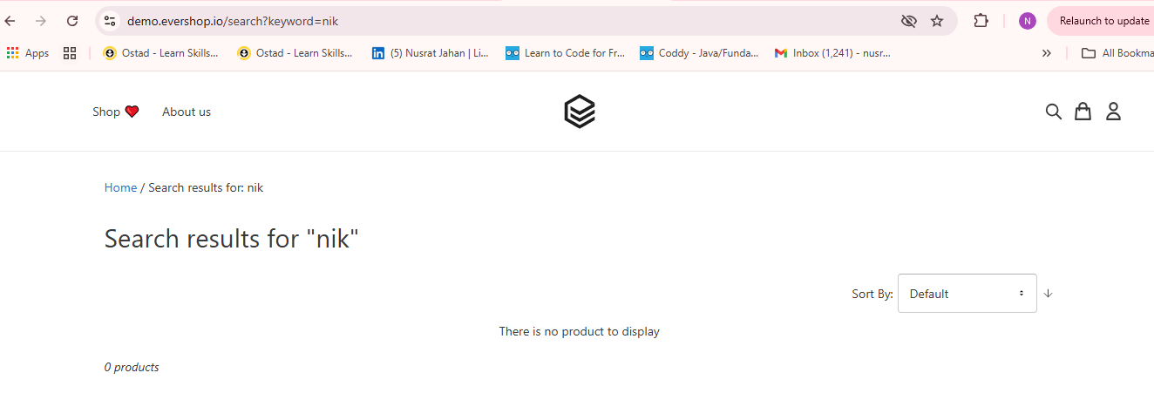
Severity: Major
Priority: High
Status: Open
Environment: Chrome (v128), Windows 10, https://demo.evershop.io/
Notes: Partial matching logic missing in search algorithm — users must enter full names to find results.

🐞 Bug Report 03
Bug ID: BUG-003
Related Test Case: Search_10
Title: Auto Suggest / Auto Complete Functionality.

Description:
The system does not provide live search suggestions or dynamically update product results while typing. Results only appear after pressing Enter or clicking the Search button.
Steps to Reproduce:
- Open https://demo.evershop.io/
- Type slowly one letter at a time — e.g., “N”, “Ni”, “Nik”, “Nike”
- Observe if results appear while typing.
Expected Result:
Search results should update dynamically
Actual Result:
Results don't update dynamically and only manual "Enter" press works.
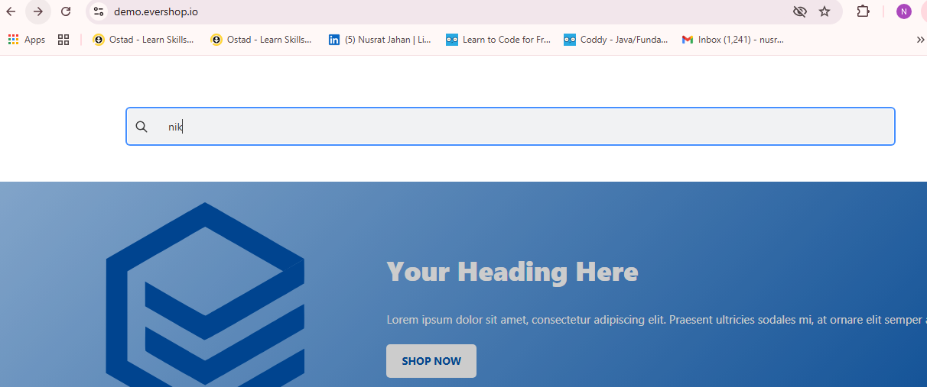
Severity: Major
Priority: Medium
Status: Open
Environment: Chrome (v128), Windows 10, https://demo.evershop.io/
Notes: Dynamic search feature either disabled or not implemented.

🐞 Bug Report 04
Bug ID: BUG-004
Related Test Case: Search_14
Title: Search feature doesn’t handle synonyms (“Sneakers” doesn’t return “Shoes”).
Description:
When searching for a synonym of “Shoes” such as “Sneakers,” the system returns no results, indicating synonym mapping is missing or not functioning.
Steps to Reproduce:
- Visit https://demo.evershop.io/
- In the search bar, type Sneakers
- Press Enter
Expected Result:
Products categorized as “Shoes” should also appear, since “Sneakers” is a common synonym.
Actual Result:
No product results are shown; message “No product to display” appears.
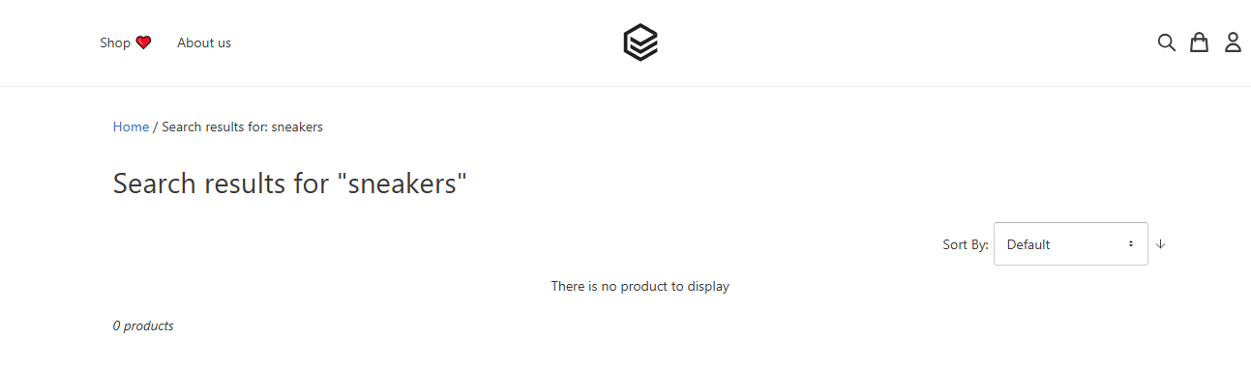
Severity: Major
Priority: Medium
Status: Open
Environment: Chrome (v128), Windows 10, https://demo.evershop.io/
Notes: Synonym mapping not configured in search index or metadata. Impacts user search flexibility.

